**L.VARSHINI**

**192372045**

**CSA1618 DWDM**

**EXPERIMENT-29**

**EVALUATING ACCURACY OF THE CLASSIFIERS**

**AIM:**

To create evaluating accuracy of the classifiers using weka tool.

**PROCEDURE:**

1. Download and install WEKA.
2. Open WEKA and Choose "Explorer" from the main menu.
3. Under Preprocess, Click on the open file button and select the dataset. Ensure that your dataset contains categorical (nominal) attributes.
4. Go to the Classify tab.
5. Click Choose and select a classifier. Examples:

J48 (Decision Tree) → trees > J48

Naïve Bayes → bayes > NaiveBayes

SMO (SVM) → functions > SMO

Random Forest → trees > RandomForest

Logistic Regression → functions > Logistic

1. Select Evaluation Method : Cross-validation.
2. Click Start to begin classification. The Classifier output section will display results.

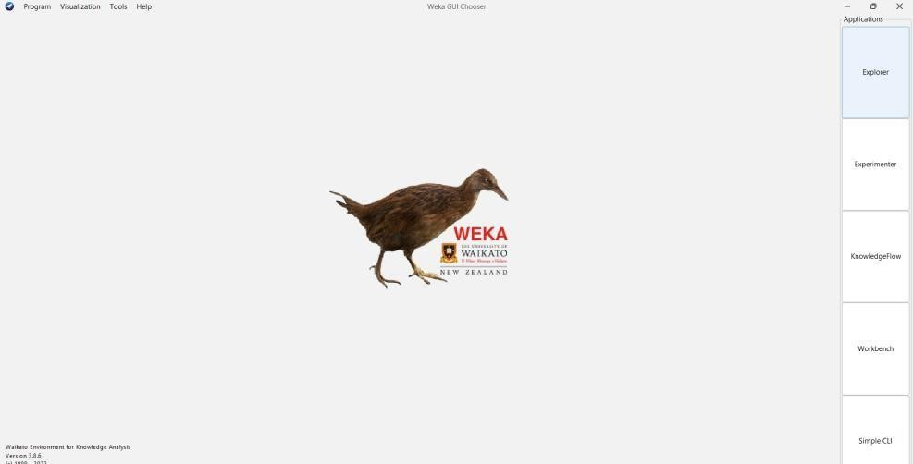

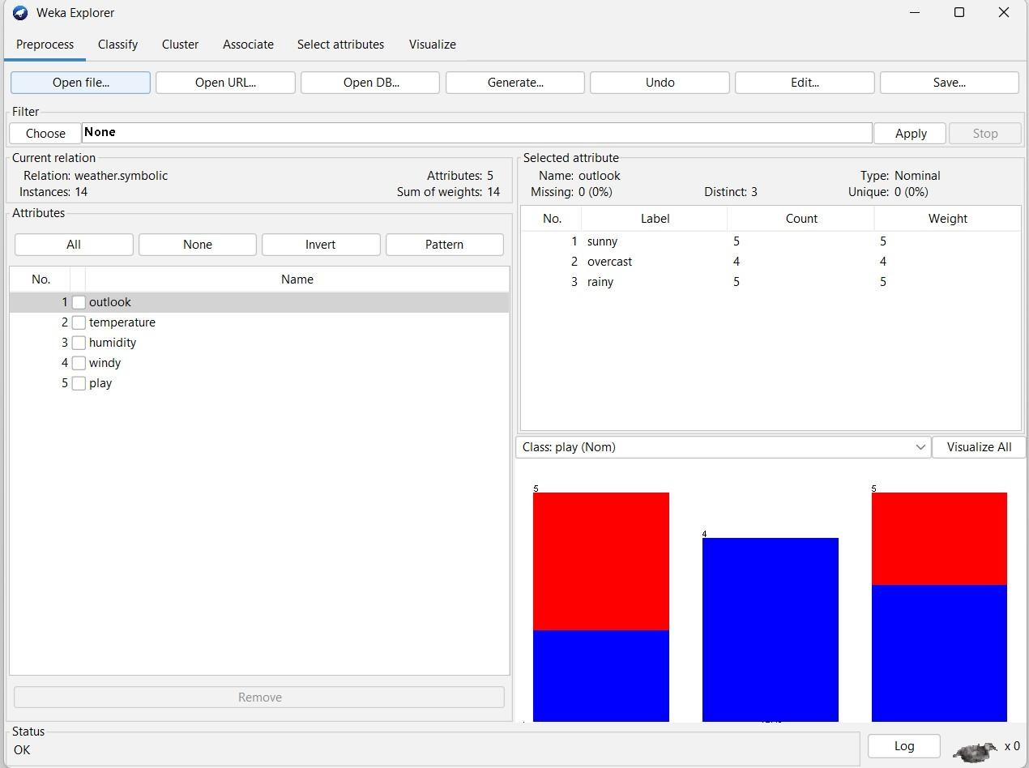

**1.J48 (Decision Tree):**

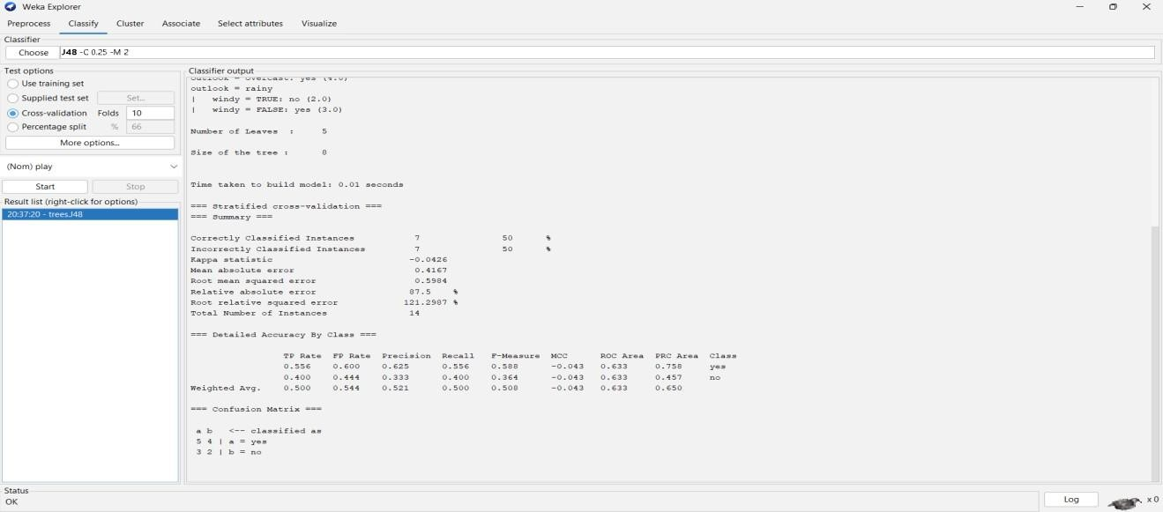

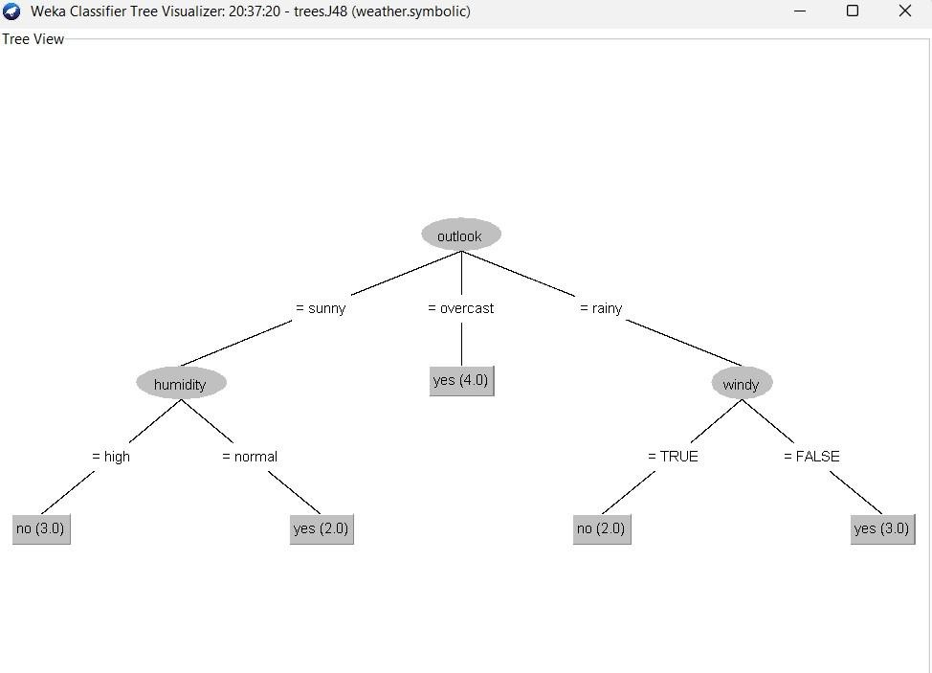

**=== Detailed Accuracy By Class ===**

TP Rate FP Rate Precision Recall F-Measure MCC ROC Area PRC Area

0.556 0.600 0.625 0.556 0.588 -0.043 0.633 0.758 yes

0.400 0.444 0.333 0.400 0.364 -0.043 0.633 0.457 no

Weighted Avg. 0.500 0.544 0.521 0.500 0.508 -0.043 0.633 0.650

**=== Confusion Matrix ===**

a b <-- classified as

5 4 | a = yes

3 2 | b = no

**2.Naive Bayes:**

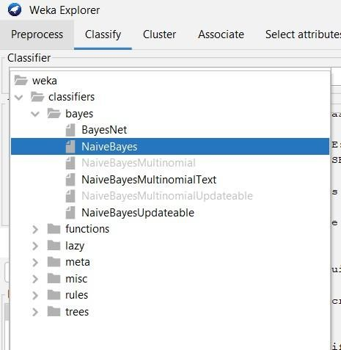

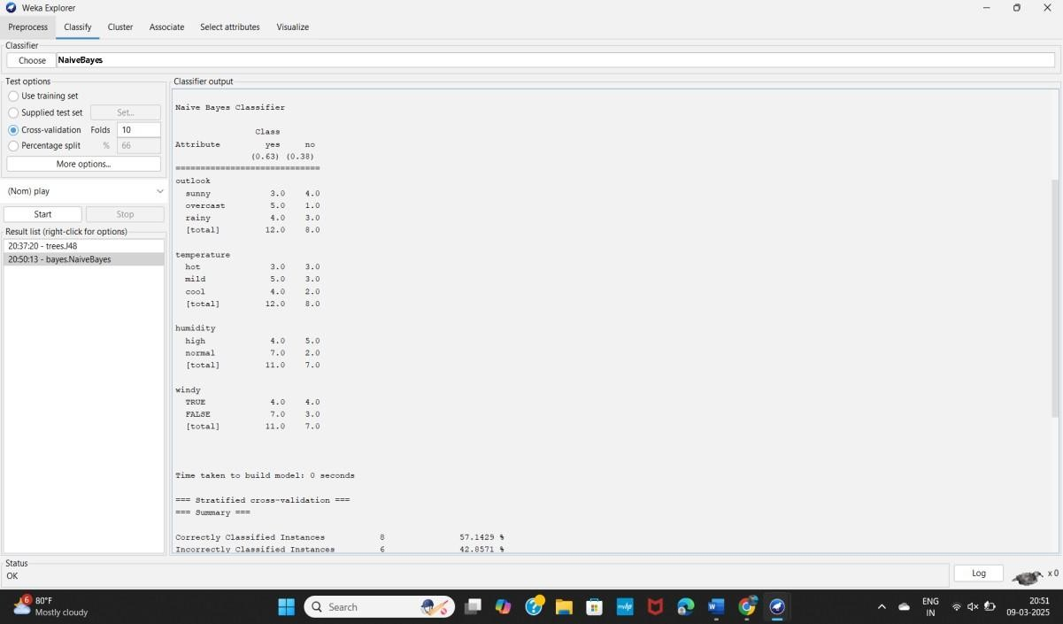

**=== Detailed Accuracy By Class ===**

TP Rate FP Rate Precision Recall F-Measure MCC ROC Area PRC Area

0.778 0.800 0.636 0.778 0.700 -0.026 0.578 0.697 yes

0.200 0.222 0.333 0.200 0.250 -0.026 0.578 0.557 no

Wt Avg. 0.571 0.594 0.528 0.571 0.539 -0.026 0.578 0.647

**=== Confusion Matrix ===**

a b <-- classified as

7 2 | a = yes

4 1 | b = no

**3.** **SMO:**

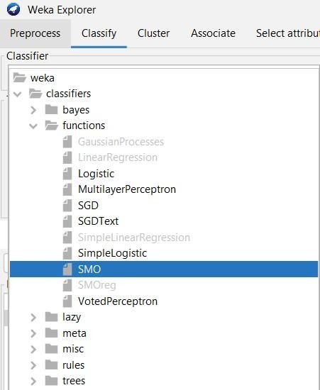

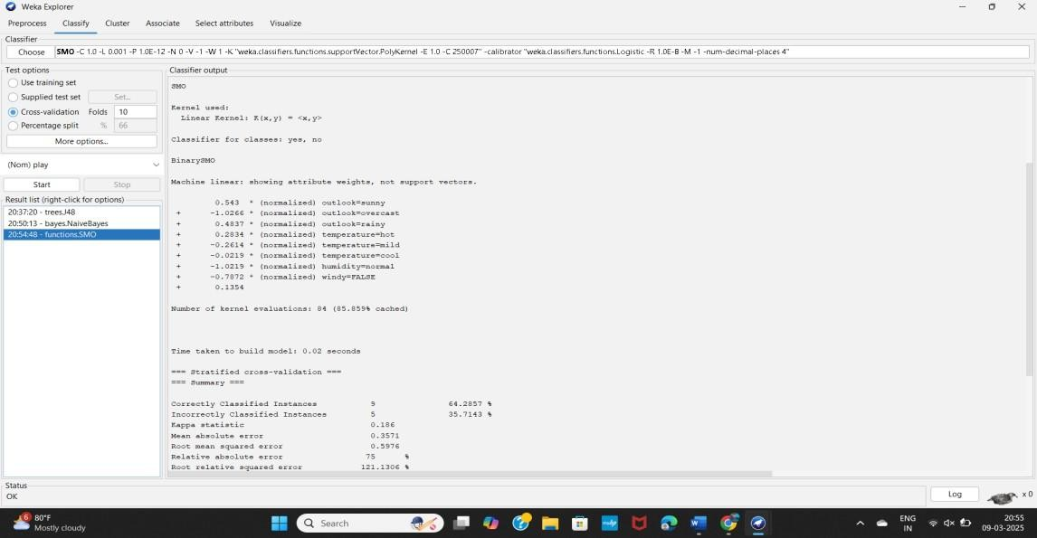

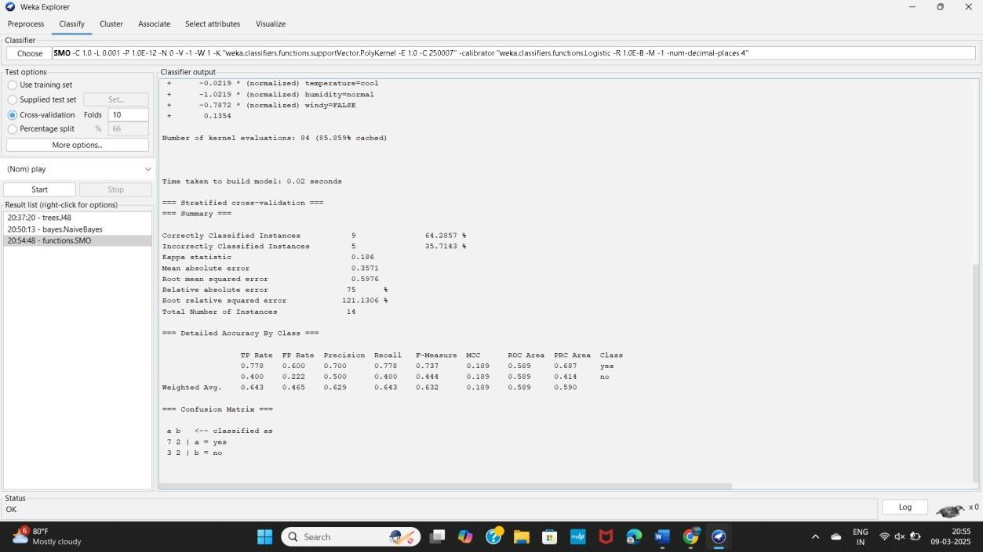

**=== Detailed Accuracy By Class ===**

TP Rate FP Rate Precision Recall F-Measure MCC ROC Area PRC Area

0.778 0.600 0.700 0.778 0.737 0.189 0.589 0.687 yes 0.400 0.222 0.500 0.400 0.444 0.189 0.589 0.414 no

Wt Avg. 0.643 0.465 0.629 0.643 0.632 0.189 0.589 0.590

**=== Confusion Matrix ===**

a b <-- classified as

7 2 | a = yes

3 2 | b = no

**4. Random Forest:**

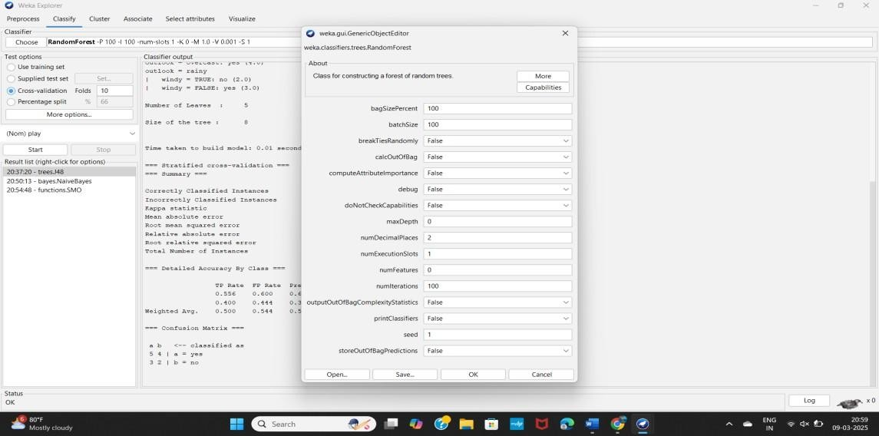

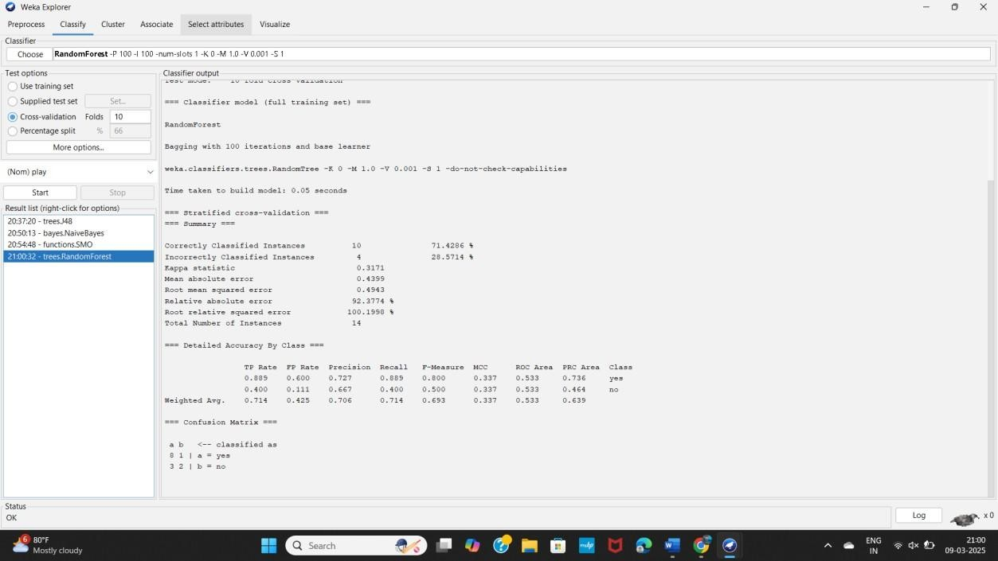

**=== Detailed Accuracy By Class ===**

TP Rate FP Rate Precision Recall F-Measure MCC ROC Area PRC Area

0.889 0.600 0.727 0.889 0.800 0.337 0.533 0.736 yes

0.400 0.111 0.667 0.400 0.500 0.337 0.533 0.464 no

Weighted Avg. 0.714 0.425 0.706 0.714 0.693 0.337 0.533 0.639

**=== Confusion Matrix ===**

a b <-- classified as

8 1 | a = yes

3 2 | b = no

**RESULT:**

Thus, the comparison of the confusion matrix for all the methods and techniques is performed. Out of the comparing matrix with all the techniques there is a change in instances. The above graphs will show the variations of values in the parameters.